The Adventures of Theseus  
Game Design Document

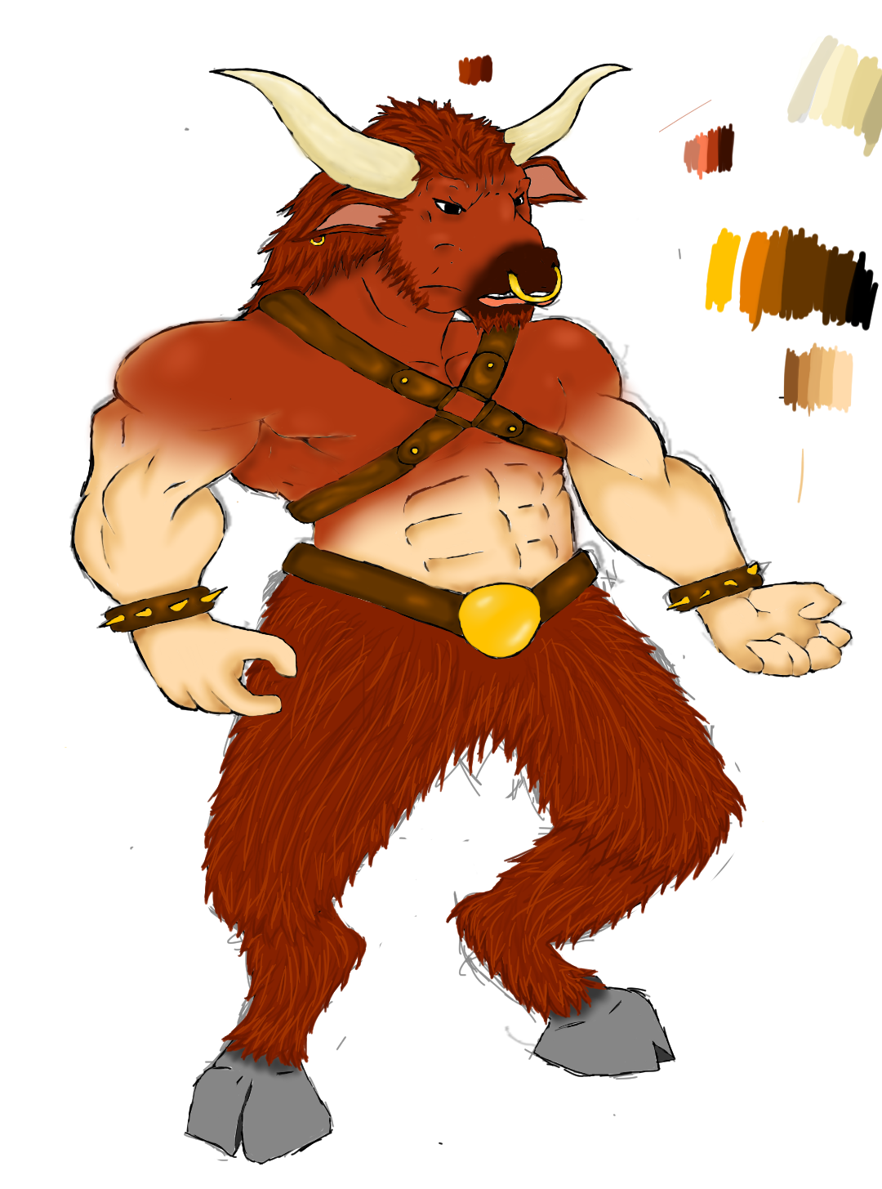

Table of contents

Summary, Story and Narrative 3

Target Audience and Platform 4

Resource Budget 5

Functional Design

Core Mechanics 6

Game Progression 7

Pickups and UI 8

Graphical Design

Art style

Level Design

Modular Assets

Characters

Enemies

UI Concept

Weapons and props

Technical Design

Code Structure

Controls

Enemies and Obstacles

UI

Introduction

# Summary

We will be making a game which follows Theseus throughout his live. In our game you will be able to play as Theseus and play through some of his famous stories like defeating the minotaur. We will not strictly follow the story but build upon it. For example: you will still defeat the minotaur but you will do so on the now flying Island of Kreta. We do this to ensure interesting levels and environment at all time. Together with this you mainly need to overcome problems by gathering items and making them into something you need by crafting. Because Theseus is more brains than raw power there will be no focus on melee combat but it will be there.

# Story

Theseus has been assigned a quest to defeat the minotaur but before he will be able to face his enemy he will need to prepare. He’ll need information on the minotaur, on how to get to the Flying island of Kreta and get the necessary equipment. After he has completed all these tasks he can finally go to Kreta, enter the Minotaur’s lair and finish him off once and for all.

# Narrative

This is the narrative for the part shown at the Demo. Theseus arrived on Kreta and is greeted by a womanly figure offering Theseus any necessary information he needs about Kreta and its inhabitants. Theseus will be able to get information on the whereabouts of the minotaur on the Island. Once at the temple he will notice that he will need to light some braziers, but not with normal fire, Greek fire. He will then have to go back to the village and talk to someone with knowledge about this fire. Luckily someone in the village knows a lot about this Greek fire and tells our hero to go find some ingredients in the forest nearby. After he has gathered everything he will be able to craft them together at the alchemy station. Then he’ll be able to light a torch with the Greek flame and set the braziers a fire which will then open the entrance to the temple. Inside the temple is a labyrinth which leads to the final boss, the minotaur. In the battle of the minotaur the player will have to dodge the minotaur’s attacks and trick him into destroying the supports of the temple, after which Theseus will have to escape the temple before collapsing.

# Target Audience and Platform

We’re aiming for people of the age of 12 or older, who enjoy a Greek history, enjoy exploring and solving puzzles. People who enjoy a niche hand painted art style with light humoristic moments.

For the target platform we are aiming for PC. Because we’re a fairly small team and none of us are experiences on console gaming we just want to bring the best we can and we think that we will achieve that best when we only have to focus on PC.

# Resource Budget

## Ploy count

For models we want to stay very low poly as it fits the cartoony style. We don’t want to make it to cubed though. For our characters we want to stay under 10 000 polys max.

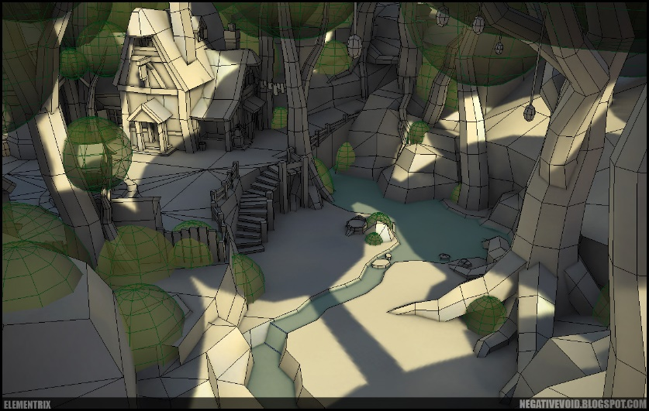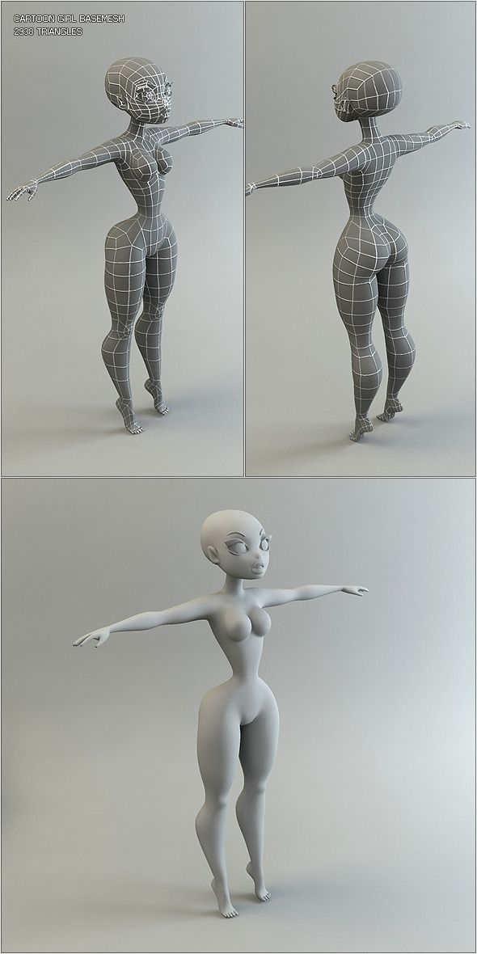

## Texture resolution

We are going for a hand painted look which won’t be to detailed so for our props we will be using 1K textures. For our characters 2K will be enough to work with. Our main boss though will be very big. And because of that we might use a 4K texture for the Minotaur.

## Environmental detail

The game will take place on floating islands. We want the player to feel touched by the surroundings and feeling of the game. We will add lots of nature and intractable features for the player to explore in between or during quests. Because the player will be put on a floating island it will be easy to keep the player in the area we want him to be. By creating a small village and setting up side quests which you can complete all over the island we keep the player busy and interested in his surroundings.

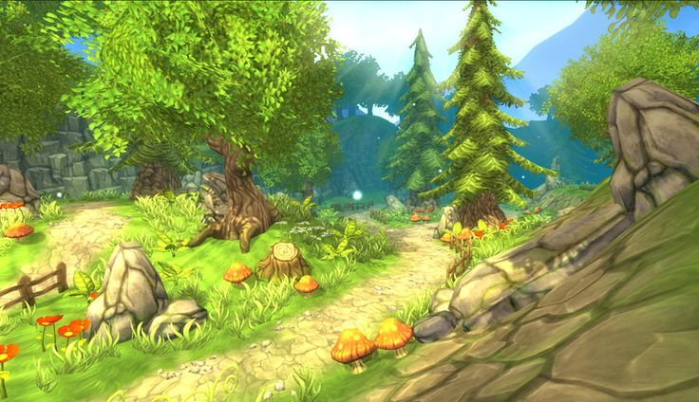

Functional Design

# Core Mechanics

## Movement

You’ll be able to walk every direction and run to get around quicker. You will be able to jump to get over certain obstacles or get higher up.

## Combat and Gathering

You’ll be able to attack with your sword. Although combat will be more about outsmarting your enemy. With combat you’ll also be able to obtain items from creatures like animals.

## Inventory and Crafting

Your inventory will hold items you have picked up. If you get to a crafting station which can be an alchemy station for a campfire, you’ll be able to craft your items into something you need to bypass obstacles or complete quests.

# Game Progression

This is the progression for the demo shown. To progress in our game you’ll have to bypass obstacles. One of the obstacles is the Greek fire puzzle. You’ll be required to light the braziers at the temple to enter. To know how to make this fire you’ll need to talk to the villagers. All of them will give you information which will be useful to progress. Then inside you will have to find your way through the labyrinth to find the boss battle. To win the boss battle you will have to observe your surroundings and observe the move patterns of the minotaur.

# UI and Pickups

In our game you can pick up items that you will be able to craft with but also (if its food) consume for healing. All these items will appear in your inventory. Inventory is part of your ingame menu.

The ingame menu consists of the following tabs

* Inventory
* Journal
* Options

In the hud of the player you’ll find your current health and current objective. When fighting a boss you’ll also be able to see the boss’s health

Your health will only be shown when taking damage. After a delay it’ll disappear

When talking to villagers a dialogue box pops up that will display what the villager is saying. After he/she is done talking you’ll get a few dialogue options.

Technical Design

# Code Structure

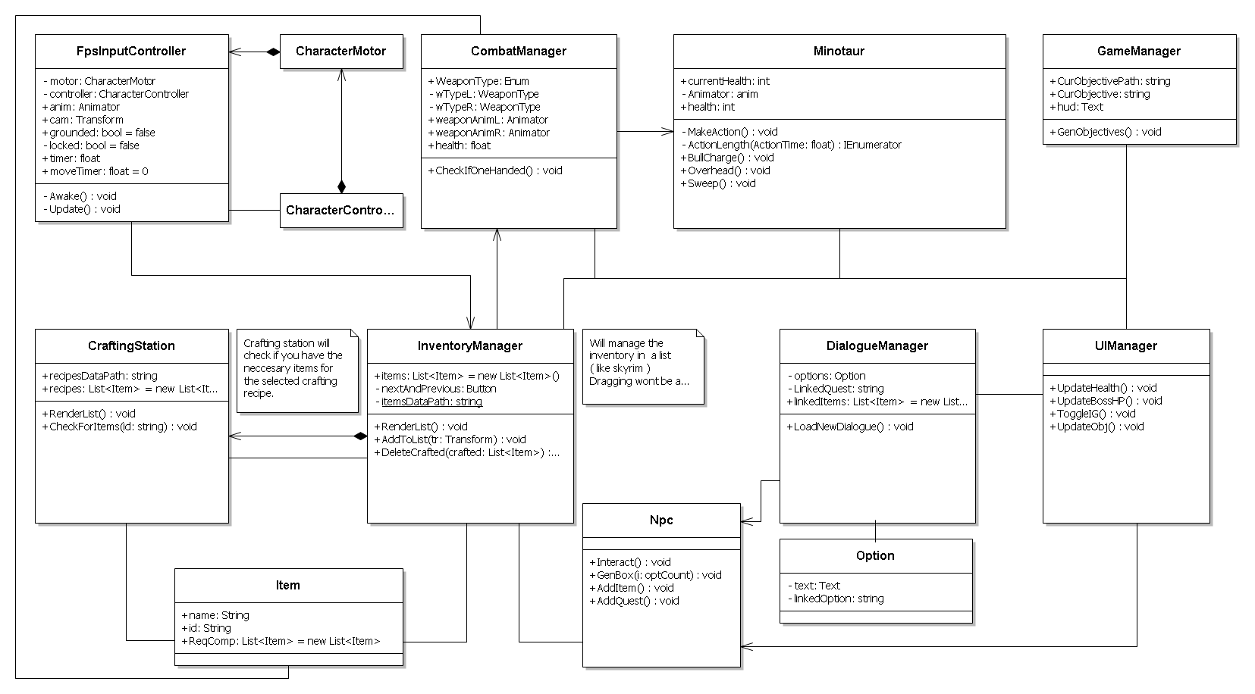

# Controls

We’ll be using the WASD keys to move.

Mouse movement for controlling which way you’re looking.

Left is attack with left hand object

Right is attack with right hand object

E key is to interact with npc’s, puzzles or pickup items. You’ll interact with the object in the middle of your screen.

B key to open the ingame menu and to close it aswell.

In the dialogue you will be able to select a response by pressing one of the number keys.

# Enemies and Obstacles

## Minotaur

For our vertical slice we’ll have the Minotaur as only enemy.

The Minotaur will be the final boss and reside inside the Temple atop of Kreta. The player will first have to find his way through the labyrinth before facing the boss. The boss will be around 4-5 times bigger than the player. When entering the boss room, you’ll have a little cut scene showing off the huge beast.

### Attack patterns

The minotaur has a few different attack:

* Overhead weapon attack
* Bull charge
* Horizontal weapon sweep

He will be going through these attacks and increasing his speed depending on a few variables:

* Distance from player
* His health
* His position in the ring (he will not sweep if he’s close to a wall)

### Way to defeat him

When the Minotaur hits a wall with his Bull charge he’ll stagger for bit and you’ll be able to attack him without fear. When he’s low to finish him off you’ll need to lure him into using his overhead weapon attack to destroy the temple’s support beams so that the roof will collapse on him. After that the player will have to make a heroic escape.

## Temple Entrance

At the temple entrance the player will discover that to enter the temple he will have to make Greek fire (this will be made clear by something on the wall or by talking to the npcs). The player will then know by asking the man in the village what the recipe for Greek fire is and then go to the forest to harvest these ingredients. The ingredients can be picked up from bushes, the ground or by hunting animals. After gathering all the necessary ingredients, in the alchemy station you’ll be able to create Greek fire to light the braziers at the temple entrance. First you throw in the substance you made in the brazier and then you light it with a spark. Obstacle

Graphical design

# Art Style

For our game we chose a cartoony, hand painted art style. The style will be comparable with the game World of Warcraft. The characters will be a little more out of proportion. We will make sure the heights and proportions of the assets will fit the rest of the art style.

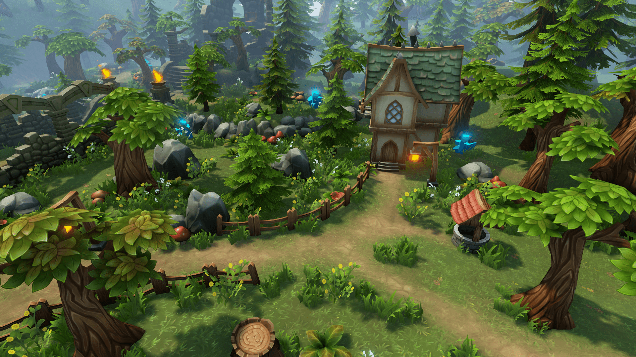

# Level design

We want to create a floating island for our level. Floating rocks and giant trees. The temple where the boss fight will take place will be on a different floating island. The island will be filled with trees, bushes flowers. The island will give you an open world feeling while actually you are on an island. The player will be allowed to walk back and forth on the island.

There will be rivers, waterfalls, clouds and giant rocks all over the island. At the start of the level will be a small village with some npc’s. That is where the quest will be given. From there on the island is yours. As long as you defeat the boss and finish the quest after exploring.

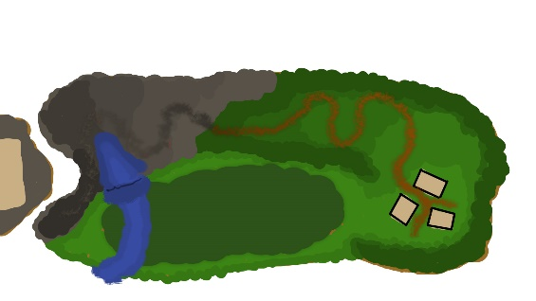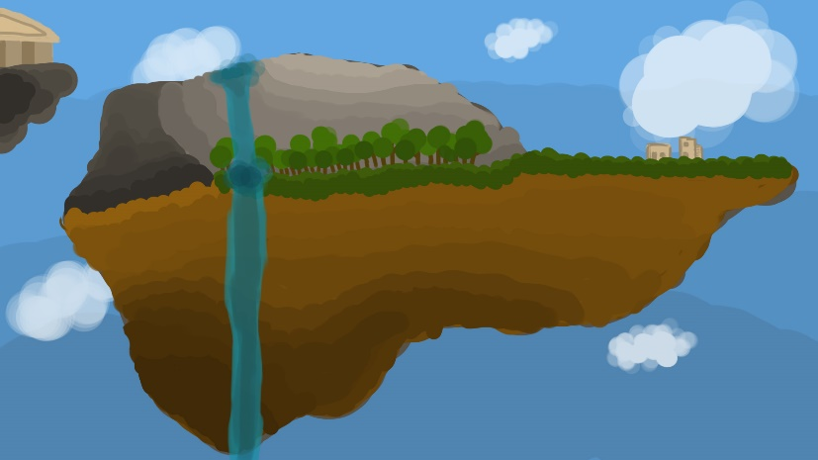

# Modular assets

For the houses and temple, we are going to create modular reusable pieces. We want to recycle as many pieces as possible. Props will be retextured and reused if necessary. The reason for this is because it gives us more play room while building the level. Its easier to change the environment.

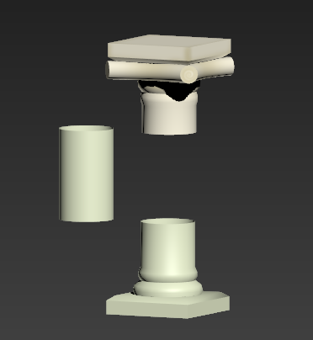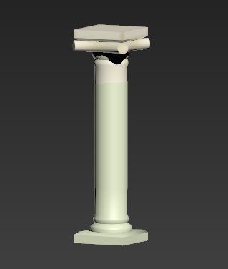

# Characters

The characters will be unrealistic. The proportions will be big and bold. Big hips? Make the bigger. Wide shoulders? Make them wider. We choose to go with a Disney like style for the characters because it really accents the cartoony look and fits the rest of the art style. The clothing of the characters will fit the Greek old style. Think of white robes, golden accessories and olive leaf crowns.

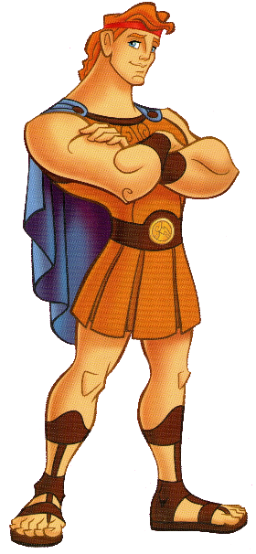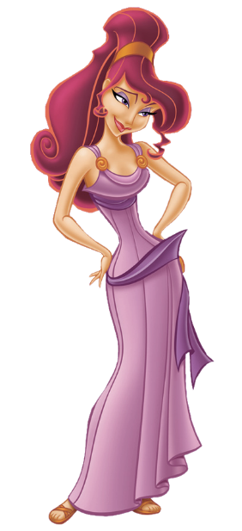

# Enemies

Our main enemy will be the great feared minotaur. He will be big, hairy and scary. He will be at the final floating island surrounded by labyrinths inside a Greek temple. When you enter his labyrinth you will need to find a way to take this beast down. Be smart. The minotaur will try to knock you down with his powerful horns. Further enemies are still being consepted.

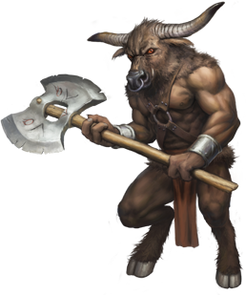

# UI Concept

You will be carrying a flat stone which beholds all the information you need. When holding the flat stone you get to see your options, inventory and journal. When you select the tab you need your character will turn the stone around showing you what you selected. Inside the inventory you can find the products you carry with you. This can be stuff you found or crafted. Options kind of speaks for itself. The journal will show you the story of Theseus. How you landed on the island and why you are there. Who you are and where you came from. The reason for the journal is to inform the player about what is going on and help them understand and connect with the game.

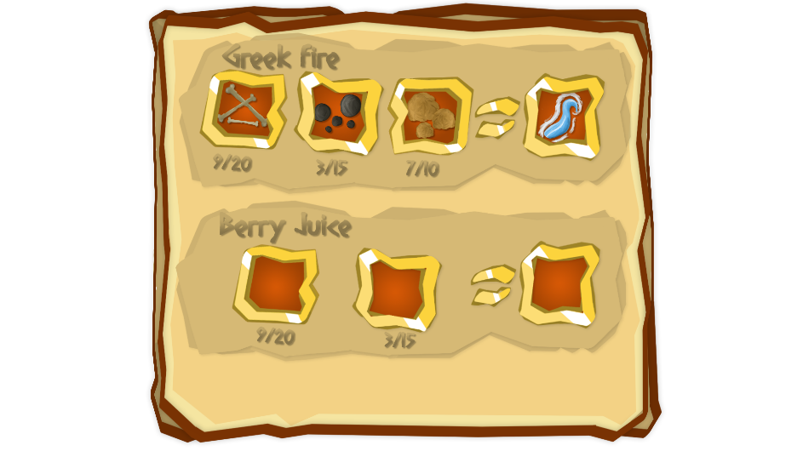

# Weapons and props

Theseus will be holding a word. The sword is called Hermes. The Weapon the minotaur will be holding will be an axe. It will be giant! Most of our props will be environmental. A lot of it will be used to fill up the level. To create a certain look and feel. Some of the props will also be used as quest items.

